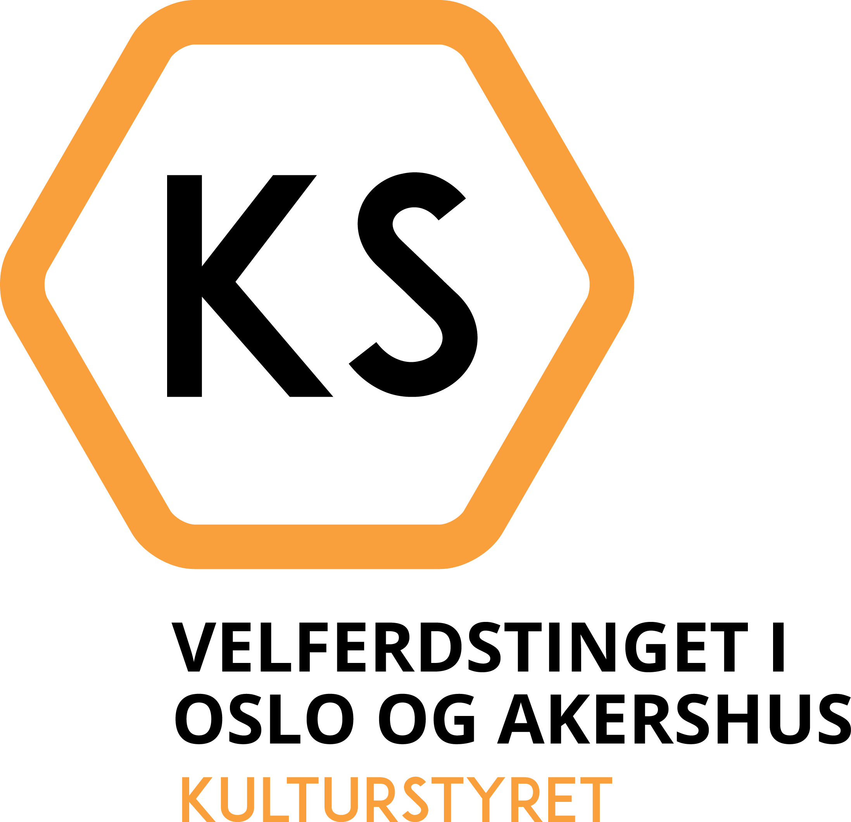
Action Plan for 2020
Topics are not listed in order of priority.

The Culture Board’s internal directives

- The board shall increase its visibility through promoting its functions
- Especially to student bodies and educational institutions where the board is less known.
- By increasing its presence on social media.

- The Culture Board shall be more accessible to applicants
- By continually improving and simplifying ways to contact The Culture Board.
- By continually improving and simplifying access to relevant information on its website
- By ensuring relevant information is accessible in English.
- By improving SiOs application portal.

The Culture Board’s external directives
The Culture Board will prioritize
- Inclusion
- Associations and activities that serve many students.
- Associations and activities that facilitate interaction between national and international students associated with SiO.
- Associations with high event frequency.
- Associations that prioritize activities that contribute to cooperation between associations and institutions.

II. Predictability
- Associations that make an impact in their environment.
- Associations that are run responsibly over time.

III. Challenge the established
- Expand student activities, especially by prioritizing associations that include students from institutions where student activities are limited.
- New associations that offer qualitatively new activities or meet new needs.
- Associations that contribute to the public discourse.
- Associations that are run effectively.

